**PROJECT-NAME: OLA CABS**

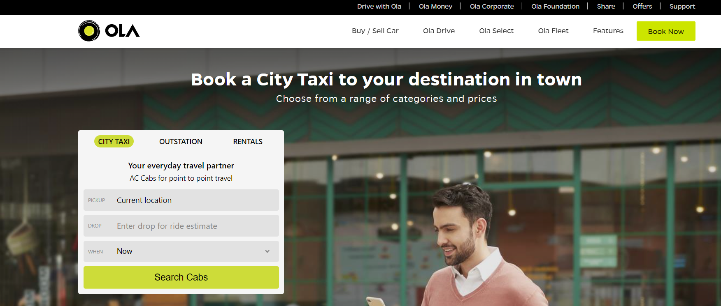

**\*OVERVIEW:** It’s an Famous e-commerce website used for various automobiles booking like cabs, auto, bikes, kaali-pili, e-rikshaw etc.

1. **HOME PAGE:**

logo

Header1 : # Drive with ola # Ola Money # Ola corporate # Ola Foundation

# support

Header2 : #Ola Drive #Ola Select #Ola Fleet #Features #Book Now

Section1 : #City Taxi # Outstation # Rentals

## Section 2 : #A car for every occasion

## Section3 : #Why ride with Ola?

## Section 4 : #Meet our Awesome Fleet (Inner hover)

Section2 : #Socials links # Discover Ola #Terms & conditions #Privacy Policies

------------------------------------------------------------------------------------------------------------------------------------------------------------------------------------------------------------------------------------------

Drive With OLA



Drive with OLA**:** It a partner portal, where anyone can sent application leasing, attaching fleet.

Login : consist of 2 options

# Using QR Code

# Using Mobile Number

Lease A Car : # Submit Apllication #Features #FAQs

# Documents Required #footer

Attached A fleet : # Submit Apllication #Features #FAQs

# Documents Required #footer

--------------------------------------------------------------------------------------------------------------------------------------------------------------------------------------------------------------------------

OLA Money



# OLAMoney Wallet #OLAMoney Postpaid # OLAMoney Credit Card # FAQs #Quick Links

---------------------------------------------------------------------------------------------------------------------------------------------------------------------------------------------------------------------

Book Now

Will Consist of 3 Options as below:

Daily Rides : #Pickup Location #Landmark #when #Rides Available

Outstations : #Pickup Location #Destination #Onetrip/Round Trip #Depart #return #Available Rides

Rentals : #Location #package #when #Available Rides

Vertical Hidden Nav Bar : #Book your ride #your Rides #share Pass #Rate card #support

Pay BY: Cash or Ola Money # Confirm and book.

---------------------------------------------------------------------------------------------------------------------------------------------------------------------------------------------------------------------